Press Release
October 2017

Steve Sabin
SETPOINT Product Manager
Phone: +1 775 552 3269
E-mail: info@bkvibro.com

Brüel & Kjær Vibro presents the unique PI System® integration of its SETPOINT® product line at the OSIsoft EMEA Users Conference

Brüel & Kjær Vibro’s SETPOINT® product line was featured prominently at the OSIsoft EMEA Users Conference in London, October 16-19. On-hand for the event were Brüel & Kjær Vibro’s President Roderik Wiedemeier, Vice-President Sales Amitabh Khosla, SETPOINT® Vice-President Randy Chitwood, and SETPOINT® Product Manager Steve Sabin. Chitwood participated in the keynote session on opening day as part of the Customer Innovation Showcases. He contrasted the traditional “stand-alone” condition monitoring data infrastructure with the approach used by SETPOINT® where a stand-alone vibration data repository is eliminated and done entirely within the PI System® instead. Chitwood’s session was a favorite among attendees, voted as one of the top two keynotes presented.
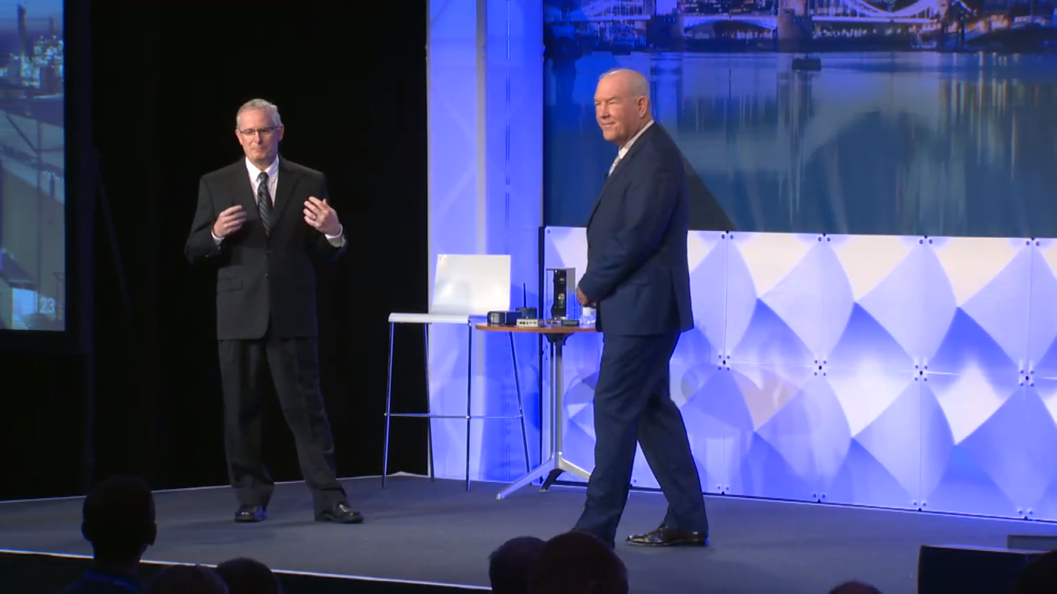
Figure 1. OSIsoft’s VP of Engineering Ray Hall (left) interviews Brüel & Kjær Vibro’s Randy Chitwood (right) as part of the morning keynote sessions on Oct 17th.

Figure 2. Brüel & Kjær Vibro’s Steve Sabin delivers his tutorial on SETPOINT technology during the afternoon IIoT track on Oct 17th.

Sabin followed later that afternoon with a 30-minute “deep dive” tutorial on the details of how the system works. He explained how intelligent analytics embedded within the SETPOINT® edge device (vibration monitor) are used to determine what data needs to be sent to the PI System® versus data that does not need to be sent, thus using network bandwidth and the PI data archive more efficiently. Sabin further explained how this approach eliminates the need for a stand-alone vibration data infrastructure but without sacrificing the functionality and data visualization requirements imposed by rotating machinery engineers and vibration analysts. A key point of his presentation was to “demystify” the mechanism whereby such high-speed data can be placed in standard PI tags and to describe how lossless compression concepts from the video streaming domain are employed to ensure that important data is never lost while unimportant data does not need to be repetitively transmitted.

A video showcasing a SETPOINT® installation at BASF’s chemical Verbund site in Ludwigshafen, Germany was included in both presentations. The entire presentations can be viewed on the following OSIsoft® links:
- Chitwood’s 15 minute keynote speech (begins at the 15 minute mark): https://www.osisoft.com/Presentations/Customer-Innovation-Showcases--Latest-and-Coming-Product-Releases-1x/
- Sabin’s 30 minute tutorial: https://www.osisoft.com/Presentations/Using-Your-PI-System-for-Full-Featured-Vibration-Monitoring/

The OSIsoft® user conference attracted more than 1070 customers and 250 partners who shared their experiences using the PI System® to achieve advanced analytics, machine learning, operational intelligence, and business insights. Two user conferences are held annually: a spring conference in San Francisco that attracts more than 3000 attendees from around the globe, and a fall session in Europe that attracts more than 1500 attendees from Europe, the Middle East, and Africa. The agenda comprises symposia, keynote speeches, industry track breakout sessions, discussion forums, developer sessions, training classes, a product expo, and more. Beginning in 2018, these User Conferences will become known as PI World.

The OSIsoft PI system® is a real-time data infrastructure that is used by more than 60% of Brüel & Kjær Vibro’s customers in the power generation, hydrocarbon processing, pulp & paper, cement, water / wastewater, and other machinery-intensive industries as an operational data historian. The relationship between OSIsoft® and the SETPOINT® system began when SETPOINT® was being developed in 2011, culminating in a formal partnership in 2014. The partnership was renewed in August, 2017 as part of Brüel & Kjær Vibro’s acquisition of SETPOINT®. Many customers choose SETPOINT® because of its tight integration to their existing PI System and the ability to eliminate the infrastructure associated with third-party software. Other customers who are not PI users select SETPOINT because of its advanced capabilities and integrate its “PI Inside” capabilities to their own data historian. SETPOINT® technology can act as both an API 670-compliant machinery protection system and as a condition monitoring device, and the two capabilities can be de-coupled from one another if needed, allowing it to work with a customer’s existing machinery protection system.

656 words, 4496 characters total

Company

Brüel & Kjær Vibro is the leading worldwide independent supplier of condition monitoring solutions for rotating machinery. The comprehensive product range comprises vibration sensors (acceleration, velocity and displacement), vibration monitors, handhelds and rack-based plant-wide integrated monitoring solutions. These products plus a suite of comprehensive services fulfill the most demanding applications for safety, condition and performance monitoring of rotating machinery. Monitoring in the hydrocarbon processing, conventional power, hydropower and wind power industries is a strategic area of focus.

Based on 60 years of experience and a world-wide sales and support network, Brüel & Kjær Vibro’s monitoring solutions have successfully reduced downtime and maintenance costs and increased machine reliability for customers world-wide.

Brüel & Kjær Vibro is part of Spectris plc, the leading supplier of productivity enhancing instrumentation and controls.

